**Report on Marginalised people**

**Rajasthan, India**

Ref.No. :- DU/Eng/02/2021

Date :- 20 February 2021

To :- Mrs. Shruti Jain , Teacher

From :- Avinash Gautam , Student

**Subject : Reality of marginalised people during Covid.**

As per your instruction, I searched about the marginalised people and their conditions during Covid. I found various facts that I have mentioned below.

Senior citizens, homeless people, racial/cultural minorities, women & children, physically or mentally disabled people and scheduled caste and tribes are considered as marginalised people in India. During covid every person had to face many problems.

1.Unemployment :-

WHO (World Health Organisation) announced COVID as global pandemic on March 11, 2020. Then many countries had strict actions like lockdown and many more. Because of lockdown most of the factories have closed and many labourers had to lose their jobs. According to the global report at least 120 million people in India lost their jobs.

According to the report of Centre for Monitoring Indian Economy ( C.M.I.E.), After lockdown there was a highest unemployment rate 23.52% in the month of April 2020. Now the unemployment rate is 6.53%.

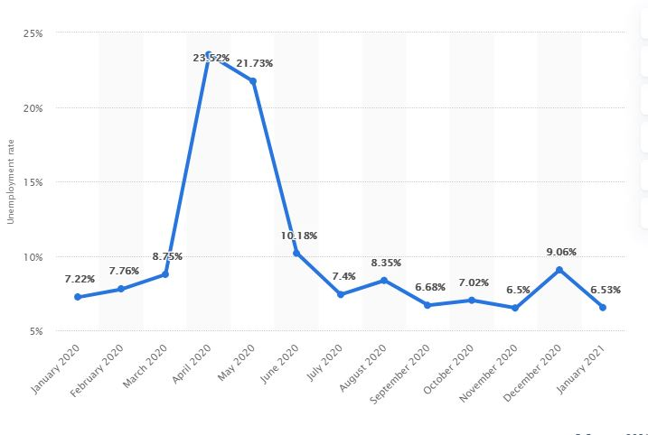Most of the labourers had to go their home back because they did not have any remaining source of income.

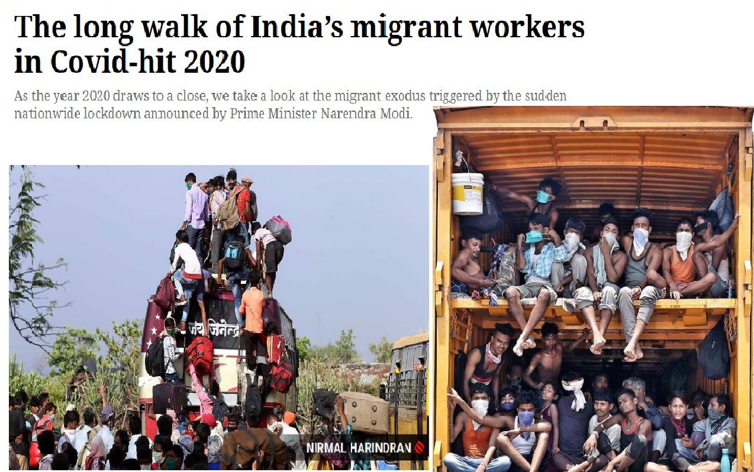

2.Impact on Food Supply :-

The Indian government announced a strict national lockdown to fight COVID-19 on March 24, 2020. One particular policy concern in this context had been whether food supply chains can remain functional in the face of a national lockdown, or whether food shortages would exacerbate the welfare costs of the lockdown. Food arrivals in wholesale markets dropped by 64% on average in the month following the lockdown while wholesale prices rose by about 10%. The fall in volume comprised both extensive and intensive margin changes as India witnessed the shutting down of a number of agricultural markets following the lockdown as well as a fall in volume of food arrivals in the markets that remained functioning. Second, after the first phase of the lockdown ended, volumes steadily recovered, reaching similar levels to those in 2019, while prices gradually returned to a declining trend.

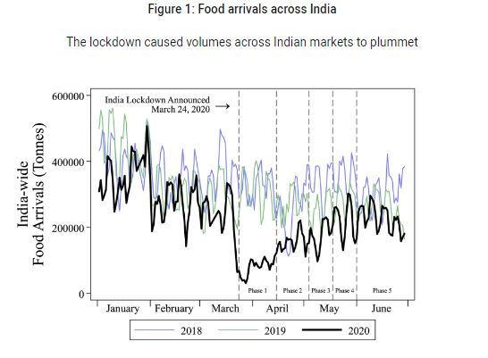

3. Impact on Mental Health :-

During COVID , Young adults had experienced a number of pandemic-related consequences, such as closures of universities and loss of income, that contributed to poor mental health. During the pandemic, a larger than average share of young adults (ages 18-24) reported symptoms of anxiety and/or depressive disorder (56%). Compared to all adults, young adults were more likely to report substance use (25% vs. 13%) and suicidal thoughts (26% vs. 11%). Prior to the pandemic, young adults were already at high risk of poor mental health and substance use disorder, though many did not receive treatment.

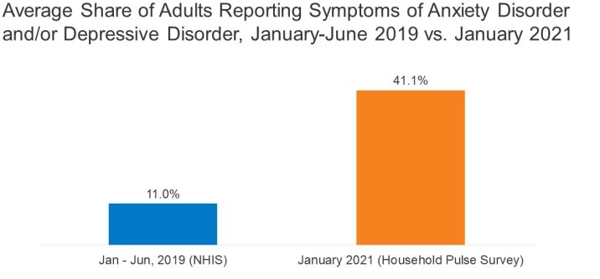

A study examining suicidal behaviour during India’s COVID-19 lockdown by the International Journal of Mental Health Systems had found a 67.7% increase in online news media reports of suicidal behaviour.

The study titled Analysis of news media reports of suicides and attempted suicides during the COVID-19 lockdown in India said that there were 369 cases of suicides and attempted suicides during the COVID-19 lockdown compared to 220 reported suicides in the corresponding dates in 2019.

There were also notable differences between the two

years in terms of the methods used for suicides and attempted suicide. During the COVID-19-induced lockdown, more suicides were reported by hanging (64.4% vs 42%), fewer cases of poisoning (8.5% vs 21.5%) and fewer cases of jumping in front of a train (2% vs 9.4%).

The COVID-19 pandemic has infected approximately 111 million people and the death toll has surpassed 2.46 million across the world. India too has borne the brunt with cases increasing each day. The first case of COVID-19 in India was reported on January 30, 2020 and as of June 7, 2020, confirmed cases stood at 2.4 lakhs with more than 1500 deaths in the past. The impact of the pandemic is visible across the sectors globally, but its impact on marginalized sections, women and children were immense in India. Women are at greater risk from the health perspective. Homes which were already unsafe along with families living in poor and substandard conditions have added on to the social inequities like gender-based violence and child abuse, lack of security, money and health. Various unplanned lockdown extensions in the country made it more difficult for them to seek help for such concerns.The COVID-19 pandemic has changed the world in

many ways. Of the several implications on humanity, the issues of health, the rapid decline of economy, shortage of medicines, sanitizers, masks, and other essentials, poverty, unemployment had undoubtedly taken centre stage and each has left a mark on the lives of people.

Focus had mostly been on testing, treatment and prevention of COVID-19 but people and communities were going through various social problems as well in adjusting to the current lifestyles and fear of the disease across nations. Conditions had all the more affected the other half of the population globally and particularly in India where abrupt lockdown has brought millions below the poverty line struggling for basic needs like food and shelter which then leads to unequal share in domestic responsibilities, to violence against the vulnerable members of the household.

During COVID, most of the people such as - scrap shoppers, car and truck drivers, daily wagers, women & children, vegetable and fruit vendors, sex workers, waiters, delivery boy and employees had to face many problems. They had to lose their jobs, their lives, their loved ones. This pandemic era was a very crucial time for all of us.

But it gave a lesson that we are weak in medical and technical approach and it also gave us a new way of thinking and living.

Avinash Gautam

(Student)